User Manual – You Might Dig

# **Contents**

Contents

[Contents 1](#_Toc493445048)

[User Side 2](#_Toc493445049)

[Test Form 2](#_Toc493445050)

[Sign up 2](#_Toc493445051)

[Sign in 4](#_Toc493445052)

[Browse games 5](#_Toc493445053)

[See recommendations 6](#_Toc493445054)

[Set favourite genres and characteristics 7](#_Toc493445055)

# **User Side**

## **Test Form**

Click the bellow link to open the Testing Form. In form you will answer a series of questions that will highlight fixes or improvements we can make to the site.

[Form](https://docs.google.com/forms/d/1nYTPpTYM3ihr5zlL484RYMEdrhAN3n1vR2KpzeBTc9Q/edit)

## **Sign up**

To sign up to the site, first tap the hamburger menu in the top right, then tap Sign Up

|  |  |
| --- | --- |
| IMG_2909.PNG | IMG_2911.PNG |

Then input an email address and password, and tap Sign Up

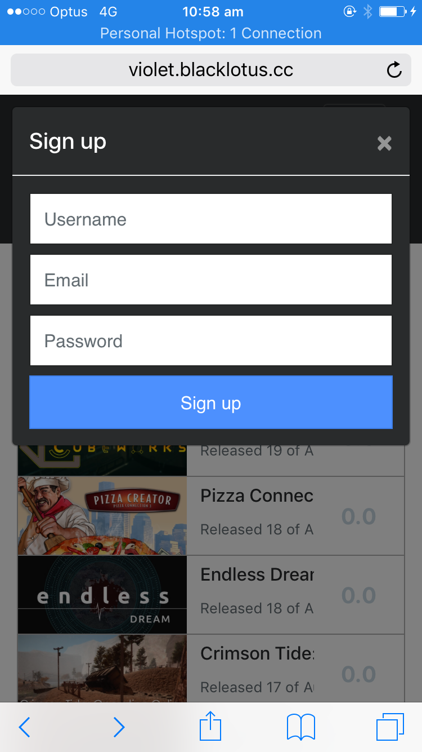

## 

## 

## **Sign in**

First tap the hamburger menu in the top right, then tap Sign In.

|  |  |
| --- | --- |
| IMG_2909.PNG | IMG_2911.PNG |

## **Browse games**

First tap the hamburger menu in the top right, then tap Browse.

|  |  |
| --- | --- |
|  |  |

Enter a search term in the box and tap Search

|  |  |
| --- | --- |
|  |  |

## **See recommendations**

Prerequisite: that you have set some favourite genres and characteristics.

Sign in first (see previous section). Then tap the hamburger icon, then “View Recommendation”.

|  |  |
| --- | --- |
|  |  |

To see a new recommendation, tap “Next Recommendation”.

|  |  |
| --- | --- |
|  |  |

## **Set favourite genres and characteristics**

Sign in, tap the hamburger icon, tap your user name, then go to Settings. Choose some genres and characteristics and press Save Preferences to save.

|  |  |
| --- | --- |
|  |  |